Set 3
- Q1. Implement a Python class for a stack data structure (`push`, `pop`, `peek`). Use GitHub Copilot to generate code, test its handling of edge cases, and explain any improvements made.
(Each question carries 5 marks)
Code:
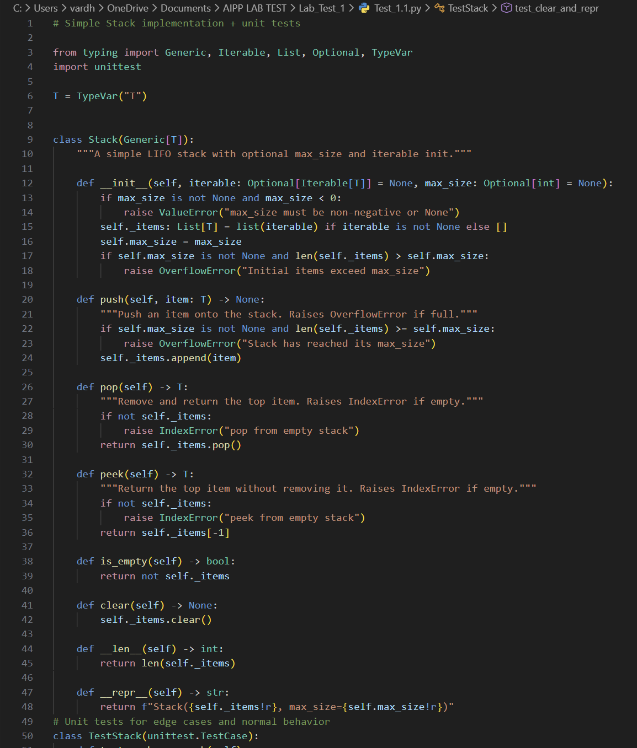
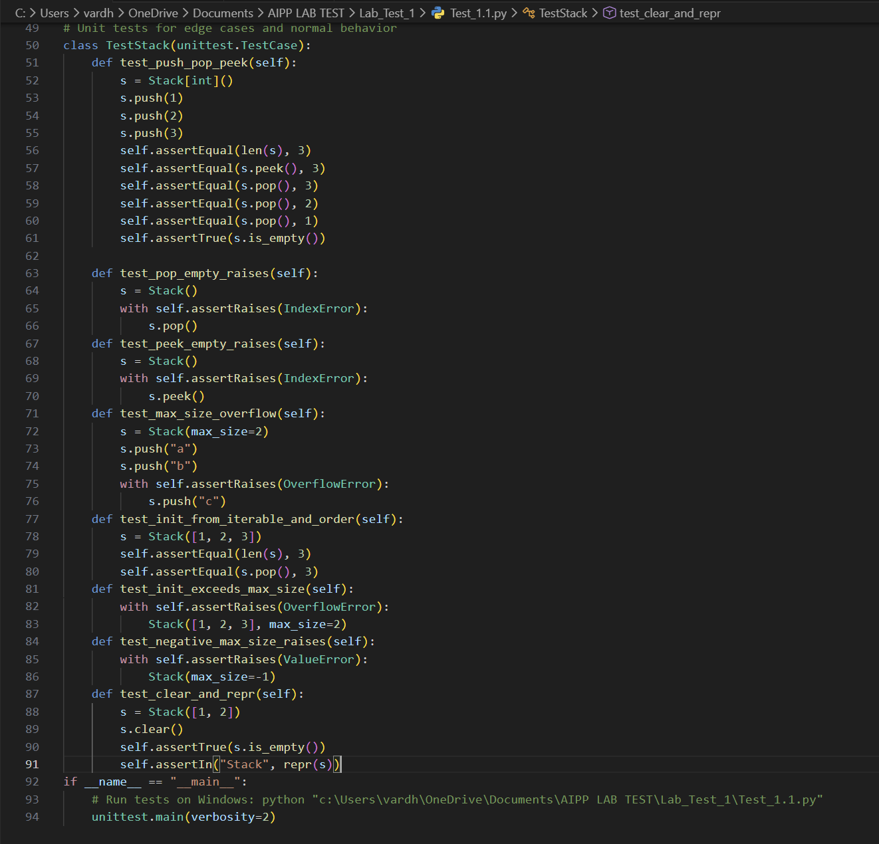

Output:
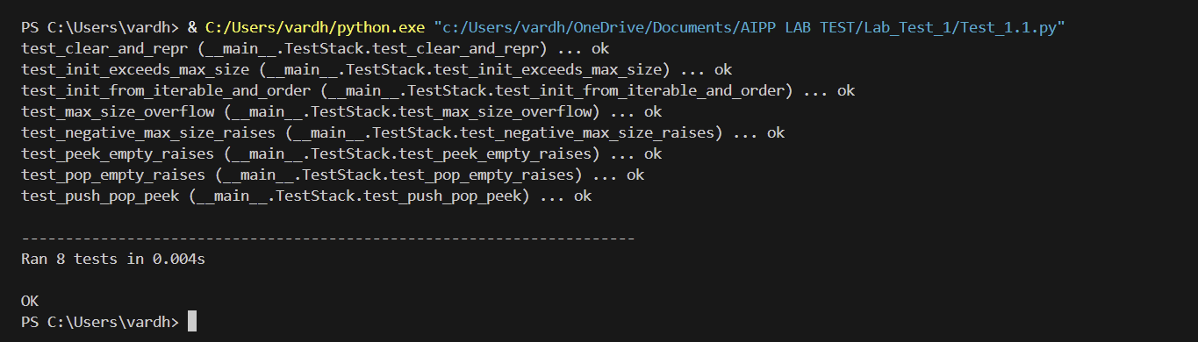

- Q2. Refactor a poorly commented Python function using an AI assistant for automatic documentation. Evaluate clarity and completeness versus manual comments.
(Each question carries 5 marks)

Code:
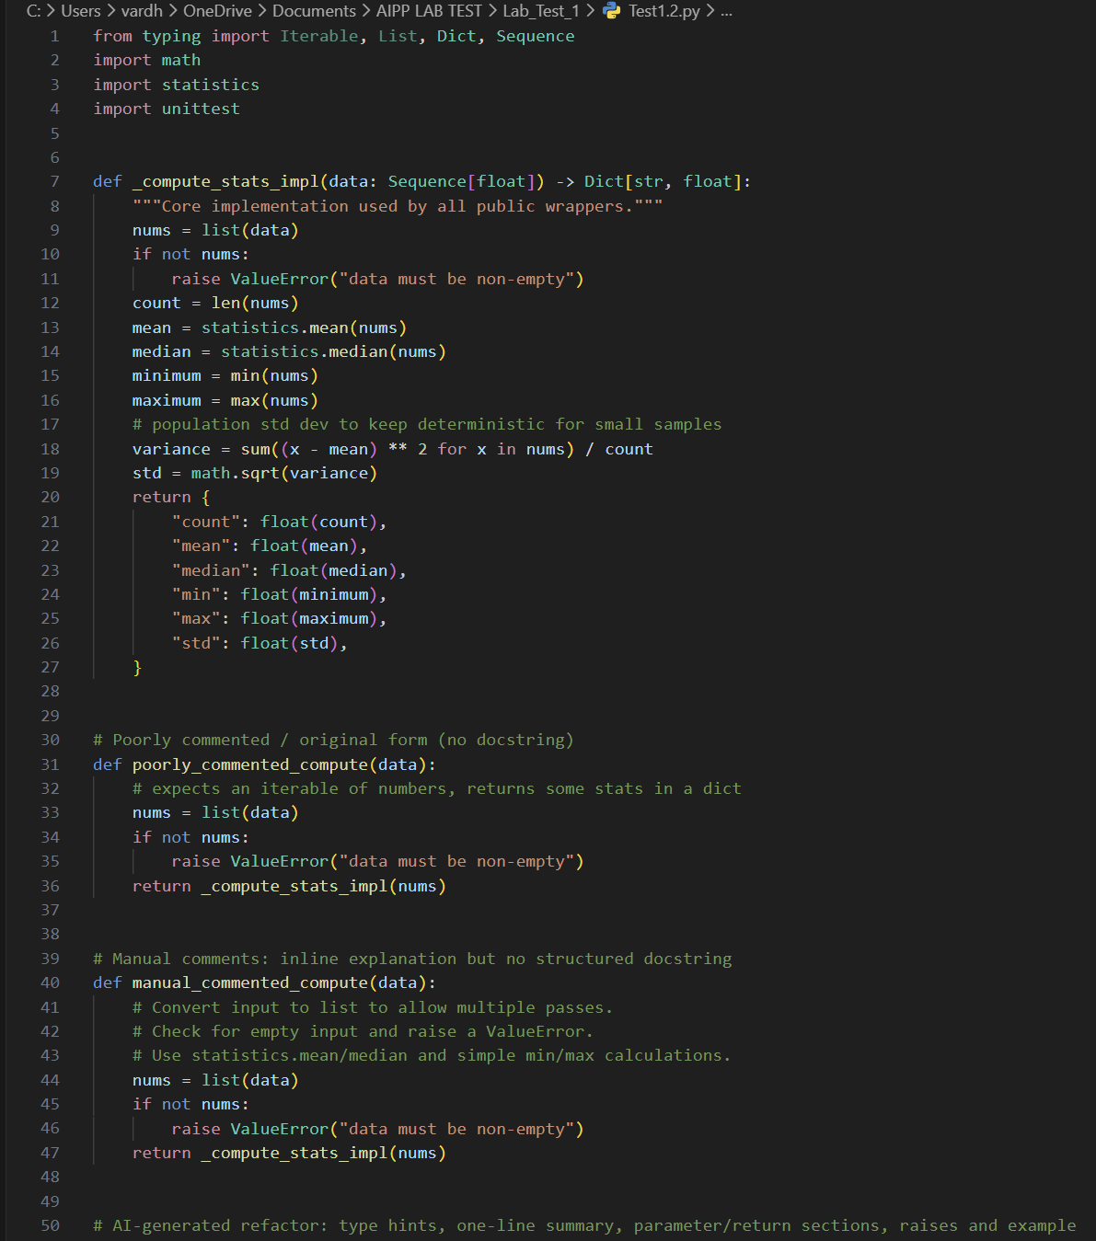
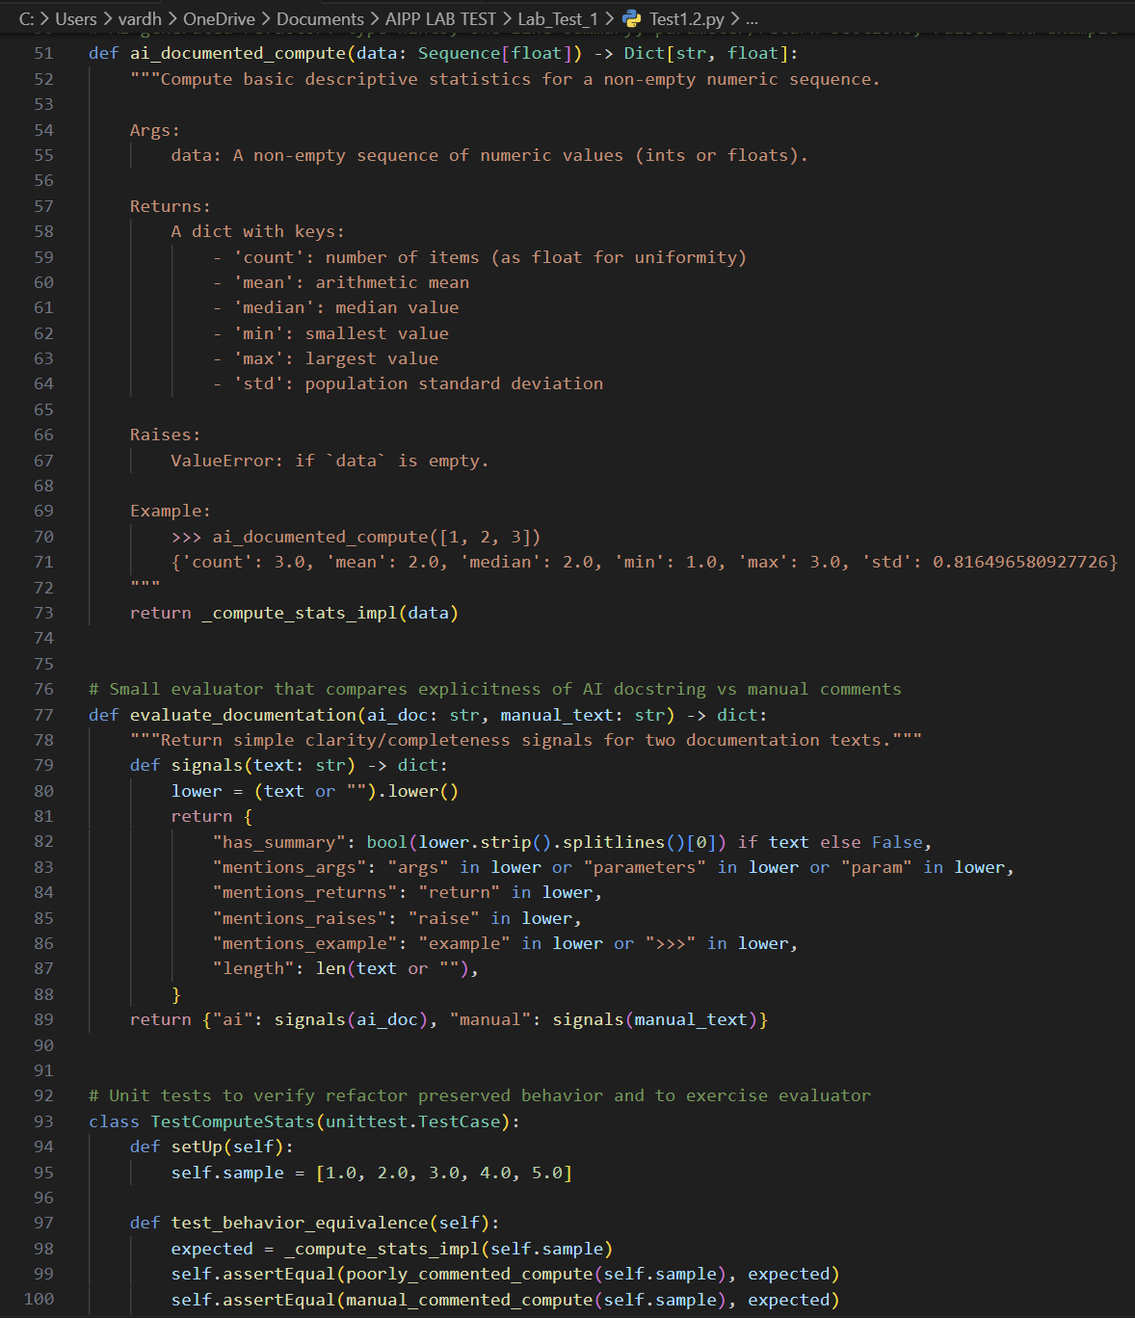
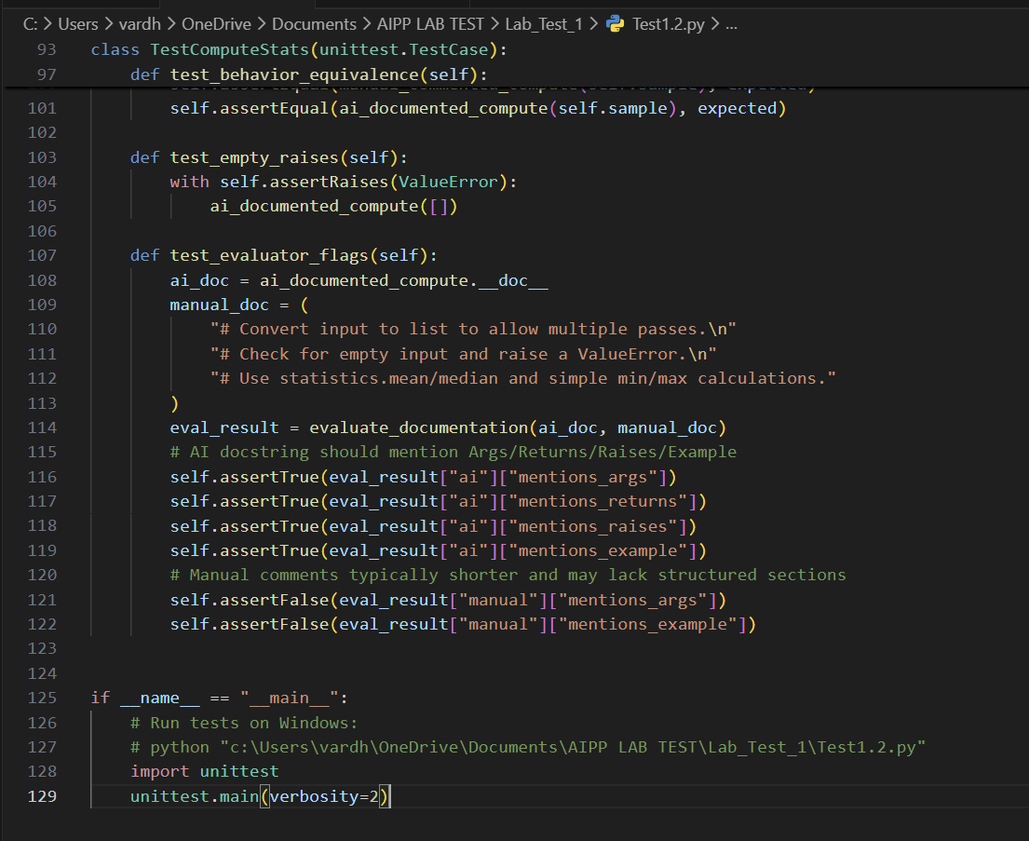

Output:
